Tatiana Ensslin

CSE 581

**Lab 10: Data Manipulation**

**Steps:**

1. Insert the following data into the tables. Make sure that the data matches perfectly!

***USERS:***

|  |  |  |  |  |  |
| --- | --- | --- | --- | --- | --- |
| **NTID** | **FirstName** | **MiddleInitial** | **LastName** | **EmailAddress** | **Password** |
| 01-HJPotter | Harry | J | Potter | [hp@hw.edu](mailto:hp@syu.edu) | Hedwig |
| 02-RBWeasley | Ron | H | Weasley | [rw@hw.edu](mailto:rw@syu.edu) | Scabbers |
| 03-HJGranger | Hermione | B | Granger | [hg@hw.edu](mailto:hg@syu.edu) | Crookshanks |
| 10-Rlupin | Remus | <NULL> | Lupin | [rl@hw.edu](mailto:rl@syu.edu) | moon |
| 11-Fflitwick | Filius | <NULL> | Flitwick | [ff@hw.edu](mailto:ff@hg.edu) | <NULL> |
| 16-Rhagrid | Rubeus | <NULL> | Hagrid | [rh@hw.edu](mailto:rh@syu.edu) | BuckBeak |

INSERT INTO Users (NTID, FirstName, MiddleName, LastName, EmailAddress, Password)

VALUES ('01-HJPotter','Harry','J','Potter','hp@hw.edu','Hedwig');

INSERT INTO Users (NTID, FirstName, MiddleName, LastName, EmailAddress, Password)

VALUES ('02-RBWeasley','Ron','H','Weasley','rw@hw.edu','Scabbers');

INSERT INTO Users (NTID, FirstName, MiddleName, LastName, EmailAddress, Password)

VALUES ('03-HJGranger','Hermione','B','Granger','hg@hw.edu','Crookshanks');

INSERT INTO Users (NTID, FirstName, MiddleName, LastName, EmailAddress, Password)

VALUES ('10-Rlupin','Remus',NULL,'Lupin','rl@hw.edu','moon');

INSERT INTO Users (NTID, FirstName, MiddleName, LastName, EmailAddress, Password)

VALUES ('11-Fflitwick','Filius',NULL,'Flitwick','ff@hw.edu',NULL);

INSERT INTO Users (NTID, FirstName, MiddleName, LastName, EmailAddress, Password)

VALUES ('16-Rhagrid','Rubeus',NULL,'Hagrid','rg@hw.edu','BuckBeak');

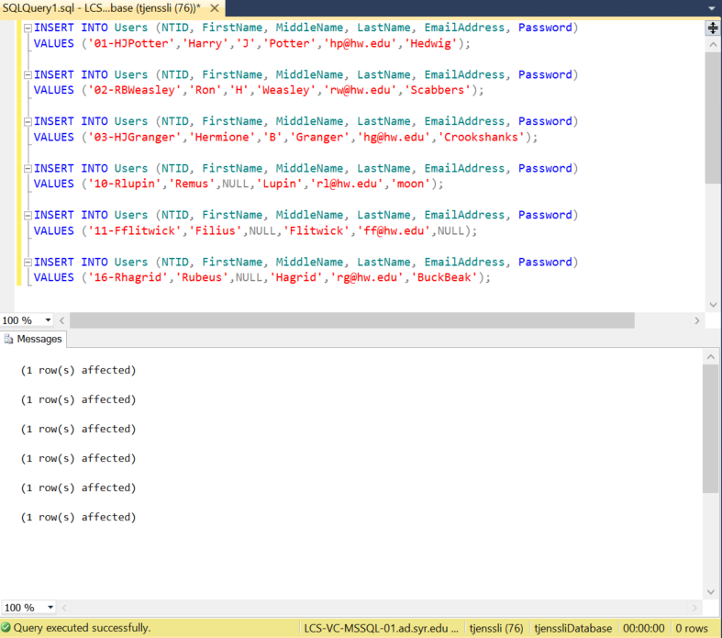

***next page***

***COURSES:***

|  |  |  |  |  |
| --- | --- | --- | --- | --- |
| **CourseID** | **CourseCode** | **CourseTitle** | **Faculty** | **OpenSeats** |
| 1 | DADA101 | Defence Against the Dark Arts BASIC | 10-Rlupin | 3 |
| 2 | DADA201 | Defence Against the Dark Arts INTERMEDIATE | 10-Rlupin | 2 |
| 3 | DADA301 | Defence Against the Dark Arts ADVANCED | 10-Rlupin | 1 |
| 4 | CHMS101 | Charms BASIC | 11-Fflitwick | 2 |
| 5 | CHMS201 | Charms INTERMEDIATE | 11-Fflitwick | 0 |
| 6 | CHMS301 | Charms ADVANCED | 11-Fflitwick | 4 |
| 7 | HOM101 | History of Magic BASIC | <NULL> | 10 |

INSERT INTO Courses (CourseCode, CourseTitle, Faculty, OpenSeats)

VALUES ('DADA101','Defense Against the Dark Arts BASIC','10-Rlupin',3);

INSERT INTO Courses (CourseCode, CourseTitle, Faculty, OpenSeats)

VALUES ('DADA201','Defense Against the Dark Arts INTERMEDIATE','10-Rlupin',2);

INSERT INTO Courses (CourseCode, CourseTitle, Faculty, OpenSeats)

VALUES ('DADA301','Defense Against the Dark Arts ADVANCED','10-Rlupin',1);

INSERT INTO Courses (CourseCode, CourseTitle, Faculty, OpenSeats)

VALUES ('CHMS101','Charms BASIC','11-Fflitwick',2);

INSERT INTO Courses (CourseCode, CourseTitle, Faculty, OpenSeats)

VALUES ('CHMS102','Charms INTERMEDIATE','11-Fflitwick',0);

INSERT INTO Courses (CourseCode, CourseTitle, Faculty, OpenSeats)

VALUES ('CHMS103','Charms ADVANCED','11-Fflitwick',4);

INSERT INTO Courses (CourseCode, CourseTitle, Faculty, OpenSeats)

VALUES ('HOM101','History of Magic BASIC',NULL,10);

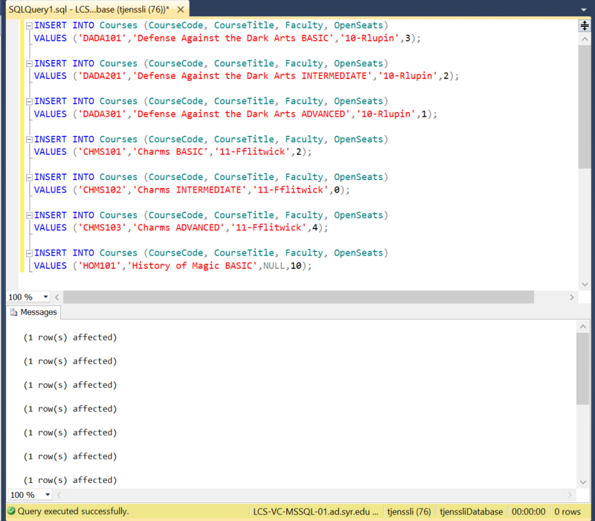

***LETTER GRADES:***

|  |  |  |
| --- | --- | --- |
| **LetterGradeID** | **LetterGrade** | **Description** |
| 1 | O | Outstanding |
| 2 | E | Exceeds Expectations |
| 3 | A | Acceptable |
| 4 | P | Poor |
| 5 | D | Dreadful |
| 6 | T | Troll |

INSERT INTO LetterGrades (LetterGrade, Description)

VALUES ('O','Outstanding');

INSERT INTO LetterGrades (LetterGrade, Description)

VALUES ('E','Exceeds Expectations');

INSERT INTO LetterGrades (LetterGrade, Description)

VALUES ('A','Acceptable');

INSERT INTO LetterGrades (LetterGrade, Description)

VALUES ('P','Poor');

INSERT INTO LetterGrades (LetterGrade, Description)

VALUES ('D','Dreadful');

INSERT INTO LetterGrades (LetterGrade, Description)

VALUES ('T','Troll');

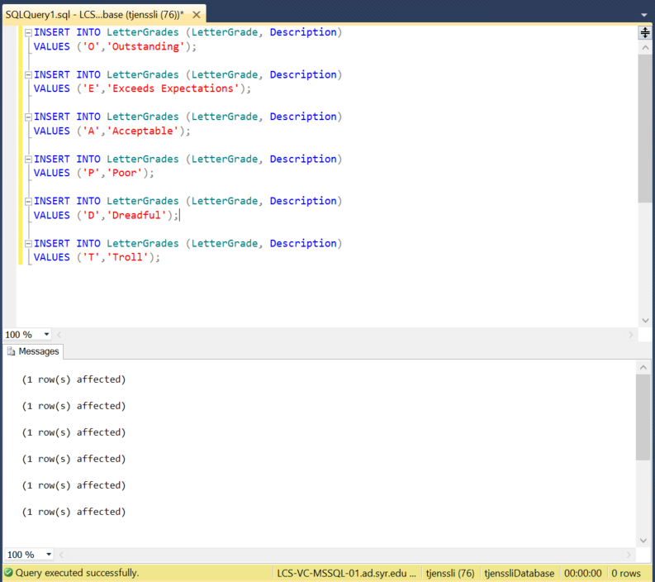

***COURSE GRADING:***

|  |  |  |  |
| --- | --- | --- | --- |
| **GradingScaleID** | **LetterGradeID** | **CourseID** | **GradeValue** |
| 1 | 1 | 1 | 95 |
| 2 | 2 | 1 | 90 |
| 3 | 3 | 1 | 80 |
| 4 | 4 | 1 | 70 |
| 5 | 5 | 1 | 60 |
| 6 | 6 | 1 | 0 |
| 7 | 1 | 2 | 100 |
| 8 | 2 | 2 | 90 |
| 9 | 3 | 2 | 85 |
| 10 | 4 | 2 | 75 |
| 11 | 5 | 2 | 64 |
| 12 | 6 | 2 | 0 |

INSERT INTO CourseGrade (LettergradeID, CourseID, GradeValue)

VALUES (1,1,95);

INSERT INTO CourseGrade (LettergradeID, CourseID, GradeValue)

VALUES (2,1,90);

INSERT INTO CourseGrade (LettergradeID, CourseID, GradeValue)

VALUES (3,1,80);

INSERT INTO CourseGrade (LettergradeID, CourseID, GradeValue)

VALUES (4,1,70);

INSERT INTO CourseGrade (LettergradeID, CourseID, GradeValue)

VALUES (5,1,60);

INSERT INTO CourseGrade (LettergradeID, CourseID, GradeValue)

VALUES (6,1,0);

INSERT INTO CourseGrade (LettergradeID, CourseID, GradeValue)

VALUES (1,2,100);

INSERT INTO CourseGrade (LettergradeID, CourseID, GradeValue)

VALUES (2,2,90);

INSERT INTO CourseGrade (LettergradeID, CourseID, GradeValue)

VALUES (3,2,85);

INSERT INTO CourseGrade (LettergradeID, CourseID, GradeValue)

VALUES (4,2,75);

INSERT INTO CourseGrade (LettergradeID, CourseID, GradeValue)

VALUES (5,2,64);

INSERT INTO CourseGrade (LettergradeID, CourseID, GradeValue)

VALUES (6,2,0);

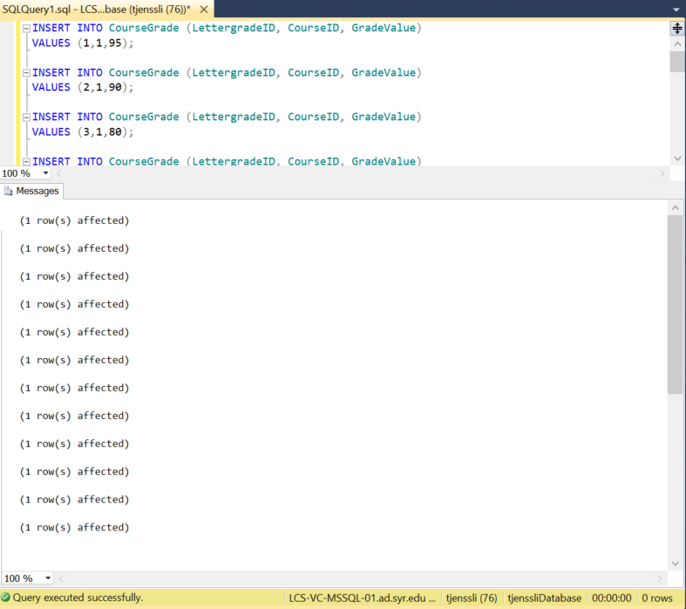

***COURSE ENROLLMENT:***

|  |  |  |  |
| --- | --- | --- | --- |
| **EnrollmentID** | **StudentId** | **CourseID** | **FinalGrade** |
| 1 | 01-HJPotter | 1 | <NULL> |
| 2 | 01-HJPotter | 4 | <NULL> |
| 3 | 03-HJGranger | 1 | <NULL> |
| 4 | 03-HJGranger | 4 | <NULL> |
| 5 | 02-RBWeasley | 1 | <NULL> |
| 6 | 02-RBWeasley | 4 | <NULL> |

***NEXT PAGE***

INSERT INTO CourseEnrollment (StudentID, CourseID, FinalGrade)

VALUES ('01-HJPotter',1,NULL);

INSERT INTO CourseEnrollment (StudentID, CourseID, FinalGrade)

VALUES ('01-HJPotter',4,NULL);

INSERT INTO CourseEnrollment (StudentID, CourseID, FinalGrade)

VALUES ('03-HJGranger',1,NULL);

INSERT INTO CourseEnrollment (StudentID, CourseID, FinalGrade)

VALUES ('03-HJGranger',4,NULL);

INSERT INTO CourseEnrollment (StudentID, CourseID, FinalGrade)

VALUES ('02-RBWeasley',1,NULL);

INSERT INTO CourseEnrollment (StudentID, CourseID, FinalGrade)

VALUES ('02-RBWeasley',4,NULL);

1. Make the following updates (use INSERT, UPDATE and DELETE, as needed):
2. Lupin has been fired. Assign his classes to Hagrid. Remove Lupin from the database.

UPDATE COURSES

SET Faculty='16-Rhagrid'

WHERE Faculty='10-Rlupin'

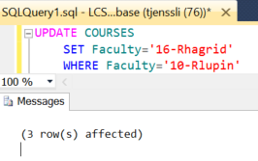

DELETE FROM Users

WHERE NTID='10-Rlupin';

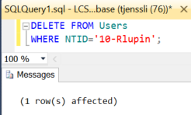

b) Harry has received a final grade of 96 in Defence Against the Dark Arts, and 91 in Charms.

UPDATE CourseEnrollment

SET FinalGrade=96

WHERE StudentID='01-HJPotter' AND CourseID=1;

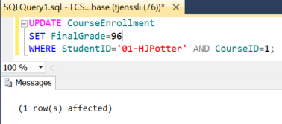

UPDATE CourseEnrollment

SET FinalGrade=91

WHERE StudentID='01-HJPotter' AND CourseID=4;

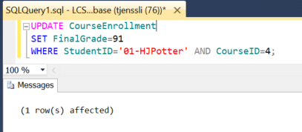

c) Ron has received a final grade of 91 in Defence Against the Dark Arts, and 88 in Charms.

UPDATE CourseEnrollment

SET FinalGrade=91

WHERE StudentID='02-RBWeasley' AND CourseID=1;

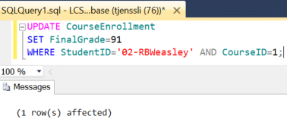

UPDATE CourseEnrollment

SET FinalGrade=98

WHERE StudentID='02-RBWeasley' AND CourseID=4;

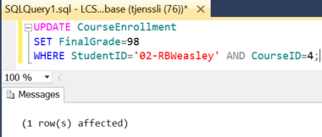

d) Hermione has received a final grade of 92.22 in Defence Against the Dark Arts, and 99 in Charms.

UPDATE CourseEnrollment

SET FinalGrade=92.22

WHERE StudentID='03-HJGranger' AND CourseID=1;

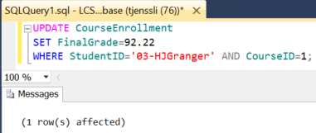

UPDATE CourseEnrollment

SET FinalGrade=99

WHERE StudentID='03-HJGranger' AND CourseID=4;

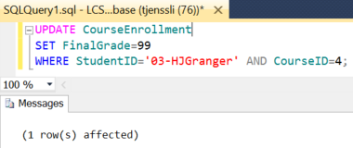

e) Enroll Harry in Intermediate Defence Against the Dark Arts.

INSERT INTO CourseEnrollment (StudentID, CourseID, FinalGrade)

VALUES ('01-HJPotter',2,NULL);

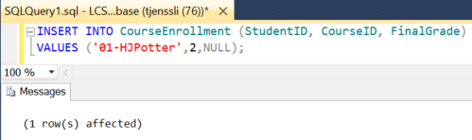

f) Enroll Hermione in Advanced Charms.

INSERT INTO CourseEnrollment (StudentID, CourseID, FinalGrade)

VALUES ('03-HJGranger',6,NULL);

